**Student Grading Management Sub-System**

**Analyze picture**

**Table 1: Assessments for Course**

*Example: DBI202*

**Fields and Attributes:**

* Category: Progress test(PT), Assignment, Labs, Practical Exam(PE), Final Exam(FE).
* Type: quiz, on-going, practical exam, final exam.
* Part: 2(PT), 1(Assignment), 5(Labs), 1(PE and FE).
* Weight: 10%(PT), 20%(Assignment), 15%(Labs), 25%(PE), 30%(FE).
* Completion Criteria: >0(PT, Assignment, Labs, PE), 5(FE).
* Duration: 20’(Each PT), 85’(PE), 60’(FE), in lab session(Labs), at home(Assignment).
* LO
* Question Type: Multiple choice, presentation, practical exercise.
* No question: 20(Each PT), 60(FE).
* Knowledge and Skill
* Grading Guide
* Note

**Table 2: Overall of subject**

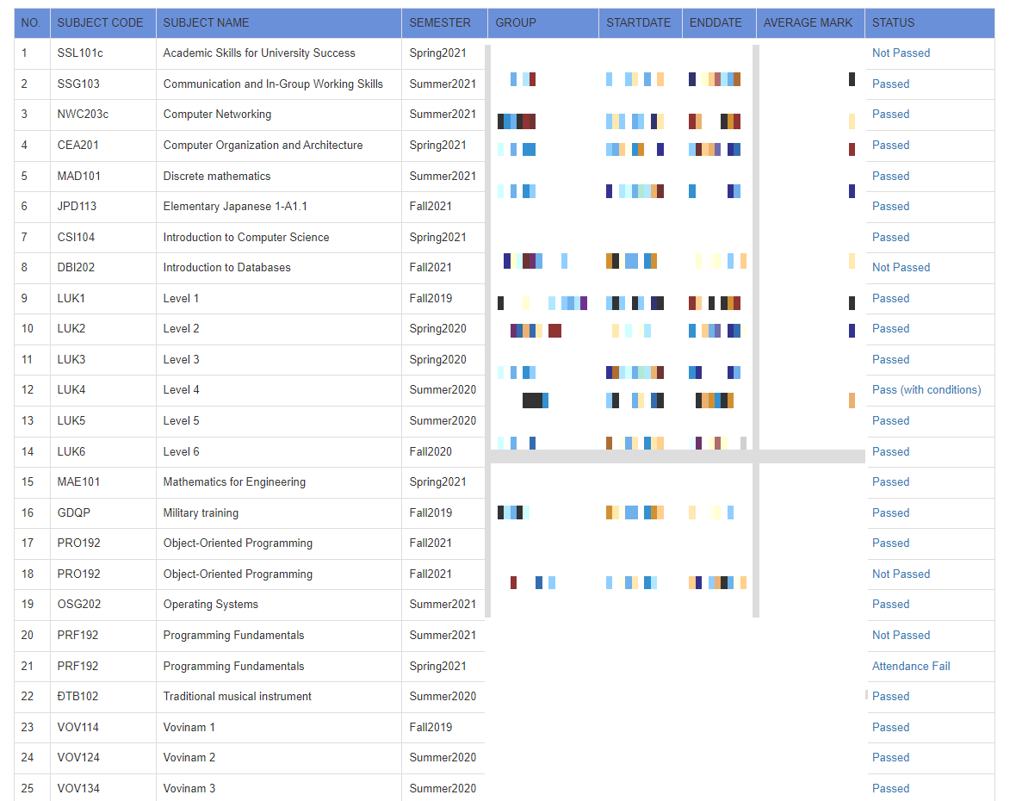

**Field:**

* No
* Subject Name
* Semester
* Group
* StartDate
* EndDate
* Avarage Mark
* Status

**Table 3: Subject Mark**

**Field and Attributes:**

* Grade Category: Quiz 1, Quiz 2, Activity, Group Assignment, Group Project, Final Exam(FE), Final Exam Resit(FER).
* Grade item: Grade Category, Total.
* Weight: 7%(Quiz 2), 8%(Quiz 1), 10%(Activity), 15%(Group Assignment), 30%(FE and FER)
* Value
* Comment
* Course total: Average, Status.

**Condition:** Total of each Grade Category > 0, FE > 4, Avarage >= 5